Proceedings of the 2014 IMECE
ASME 2014 International Mechanical Engineering Congress & Exposition
November 14-20, 2014, Montreal, Canada
IMECE2014-37455

J. Horst, H.Huang, J. Michaloski, and F. Proctor,
National Institute of Standards and Technology
Gaithersburg, MD USA
EVALUATION OF Key Performance Indicators AS supported by MTConnect

Abstract
MTConnect is a factory integration standard aimed at solving the islands of automation problem in discrete manufacturing. Machines adopting MTConnect can offer better data acquisition and thus offer the potential to better understand factory operation. However, properly assessing machine performance requires insightful metrics, such as Key Performance Indicators (KPI). The ISO 22400 standard, “Automation systems and integration Key performance indicators for manufacturing operations management” offers guidance through the definition, use, and benefits of resource and production KPI. The range and scope of ISO 22400 KPI is extensive so that understanding the standard can be beneficial to users of the KPI for implementing subsequent production improvement. In conjunction with MTConnect, this paper will explore the necessary MTConnect data requirements to satisfy ISO 22400 and then outline issues related to calculating and using the KPI. A case study of a simulated factory with of resources will be developed to show how a client MTConnect can calculate and use the KPI of ISO 22400 in a factory setting.

Nomenclature
ANSI American National Standards Institute
B2MML Business To Manufacturing Markup Language
CAEX Computer Aided Engineering Exchange
CAD Computer Aided Design
COM Microsoft’s Component Object Model
CMSD Core Manufacturing Simulation Data
CNC Computer Numerical Control
DES Discrete Event Simulation
ERP Enterprise Resource Planning
ISA International Society of Automation
HTML Hypertext Markup Language
KPI Key Performance Indicators
PLC Programmable Logic Controller
MES Manufacturing Execution Systems
MTBF Mean Time between Failure
MTTR Mean Time to Repair
MTTP Mean Time to Processing
OEE Overall Equipment Effectiveness
OEM Original Equipment Manufacturers
PLC Programmable Logic Controller
SDK Software Development Kit
UML Unified Modeling Language
XML eXtensible Markup Language
XSD XML Schema Definition
XSD XML Schema Definition

INTRODUCTION
Intuition, ‘rules of thumb’, and educated guesses are ineffective ways to measure manufacturing.
Modern production is a complex operation. Manufacturing systems involve a number of interrelated elements, including abundance of equipment, number of product options, material handling systems, system size, process flow configuration, processing time of the operations, system and workstation capacity, and space utilization. The model must be combined with other constraints such as unpredictable machine breakdowns, varying operational requirements, schedule variation, and different production demands.
Automate data acquisition process

Key Performance Indicators
Key Performance Indicators (KPI) can serve as a basis for decisions (problem identification) and for performance benchmarks (target / actual comparison) to describe and understand important production elements. Since KPI can characterize the behavior of their production, this can help manufacturer's benchmark performance. Benchmarking can be used to compare current performance against historical performance, as well as a comparison against others in industry. Depending on the perceived KPI value, companies can choose to initiate subsequent solutions to improve efficiency or not.
KPI are metrics that provide a means to characterize productivity. To help understand and implement KPI, the International Organization for Standardization (ISO) has developed a draft standard ISO 22400, “Automation systems and integration Key performance indicators for manufacturing operations management”, that offers guidance with the definition, usage, application and benefits of production KPI and associated metrics. KPIs computed for benchmarks, comparisons, estimations and forecasts are described in terms of data pertaining to the process, the machinery and equipment, the product manufactured and its quality, the manufacturing personnel and other related manufacturing resources.
Measured KPI are necessary, but not sufficient, in order to enact improvements. For example, throughput is a KPI to measure the performance of a process, i.e. the quantity per unit time is produced and is an important indicator of production efficiency. Although, throughput KPI forms a necessary basis for improvements by better production information, unsatisfactory KPI values implies the need for more detailed data analysis, that most likely is not be directly discernible from the KPI itself. Instead, production data of finer granularity is required to understand the contributing factors that lead to the unsatisfactory KPI. For example, in one scenario the machine often sits idle blocked, waiting for the arrival of materials or tooling. In contrast, excessive machine or process faults cause prolonged unproductive periods of operations. In either case, understanding the type and severity of delays or faults within production are required to remediate process problems and improve OEE. Often the underlying analysis is more difficult to undertake and the data is more difficult to categorize and remediate.
Our research goals regarding KPI are to quickly synthesize KPI and then understand the underlying root causes of poorly performing KPI.
RelateD Work

Mailboxes
Proxy agents
CASE STUDY

Cell is a vector of resource ids.
The simulated case study scope was end-to-end – from command cell to resources, from job into work orders, and archival and graphical interpretation of the results. The simulated factory is defined by using a basic skeleton of a resources, cells, part, process plans, process and job definitions.
In Figure 1, a PART is assumed to be a finished product that was produced or that can be used in production activities as raw material or a work in–progress component. Many different kinds of information can be specified for a PART, such as, information about the production status of a PART, the named category of parts that a specific PART belongs to, the sub-component parts used to create this part, the process that can be used to create the part, and some basic characteristics of this part. For a PART, there is also a PROCESSPLAN, which holds a list of PROCESS objects in some sequence. This sequence can be used to describe the routing of a PART object. Each PROCESS class holds a list of the PART Type that it requires for processing, as well as the products it creates. The PROCESS class also holds a list of the resources required for processing. These resources can include physical locations of machines and mobile resources (such as laborers or work fixtures).
Outside the scope of this case study, a customer order enters the system and if exceeding those found in the inventory, triggers a part order. The case study simulation starts with a job that will be generated containing the PART uses a process plan to describe the sequence through a set of cells. This process plan will serve as the scheduled routing but an alternate routing may be required to reroute the part fabrication if a faulted resource arises.

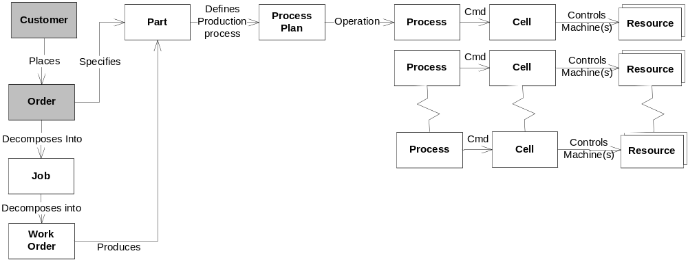
Figure 1 Factory Architecture

- Cells –describes a partition of production shop into production cells, each dedicated to the production of part families with similar processing requirements. Typically, a grouping of resources under the cell
- Resource – describes equipment that performs manufacturing activities. Resources in the CMSD are used to represent stations, machines, cranes, employees, tools, and fixtures.
- Part – provides a means to specify the characteristics of the materials and subcomponents that are used to make end products.
- Process plan – specifies the set of production activities needed to transform materials and subcomponents into finished products. Each process plan is built from process steps (with associated resource(s)) that must be executed for the part to be finished.
- Process – defines a manufacturing activity or group or manufacturing activities that encompass a detailed strategy for creating a part. The process will most likely contain information that describes the resources that will be used, the parts that will be consumed and produced, the sequence in which resources will be used, and the sequence of activities within a group of activities.
- Job –represents normal manufacturing and is the central construct of the system. Each job (assuming it came from customer order as described earlier), would generate an appropriate number of parts into “spawned” jobs (type of job) and under each spawned job contains the part knowledge exhibited within the job e.g., process plan, the resources, etc. The spawned job would contain a copy of the initial job that described all the parts and quantities.
- Work Order – represents work that is requested in order to satisfy the manufacture of a part. A work order (WO) defines a part(s) to build, and a set of instructions as defined by a process plan. A WO records the relevant metrics as the manufacturing is carried out. The total amount of hours for the WO manufacturing of the part with associated fiscal rate for each resource are used to calculate financial KPI.

The factory was designed as a cellular manufacturing system (CMS) which is a decomposition of the manufacturing system that consists of a set of machines M={M₁, M₂, …, M_{m}} into a set of cells C = {C₁, C₂, …, C_{w}}. Jobs define production work items and can involve activities at multiple cells that produce parts. Processes are lower level work items and are performed at a single resource within the shop. The basic fulfillment of a work order is to know its process plan, its current process step within the process plan (at what process), and its processing status.

MTConnect was used as the communication link between commanded and “actual” simulated resources. In order to reduce costs, increase interoperability, and maximize enterprise integration, the MTConnect standards have been developed to “open” machine tools and factory floor devices for the manufacturing industry. MTConnect is based upon prevalent Web technology including XML and Hypertext Transfer Protocol (HTTP). Figure 2shows the high-level system architecture of the MTConnect standard. An “MTConnect Device” is a piece of equipment organized as a set of components that provide data. The core of MTConnect is the “Agent”, which is a process that acts as a “bridge” between a factory device and a “Client Application”.
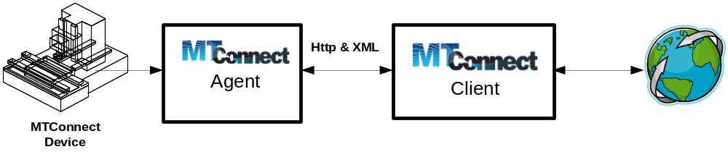
Figure 2 MTConnect Overview

The MTConnect Agent receives and stores single or a time series of data samples or events or assets that are made available to the Client Application. An MTConnect sample is the value of a continuous data item at a point in time. An MTConnect event describes an asynchronous change in state. Since MTConnect leverages the software and hardware Internet paradigm, and because of the systemic prevalence of the Internet, there is an abundance of tools to ease MTConnect development and deployment.

In the discrete parts industry, process quality metrics are integral for calculation of standard KPI. In order to satisfy quality metrics, part inspection was included within the simulation. Thus, each simulated resource has the capability to run several programs (e.g., setup, machine, inspect) per part. In our simulation scenario, resources that are at the end of process plan, did inspection and thus could randomly determine whether a part was good or bad, based on the predetermined distribution (usually uniform with given probability, for example, 90% of the parts are good, and 10% of the parts are bad). Clearly, inspection could be done at each phase of a process plan on every resource in order to determine scrap, but this is rarely found in real manufacturing environments.
Thus, the procedure done in simulation to calculate part and process quality involves invoking an inspect program from the commanded resource device to the simulated resource using MTConnect.

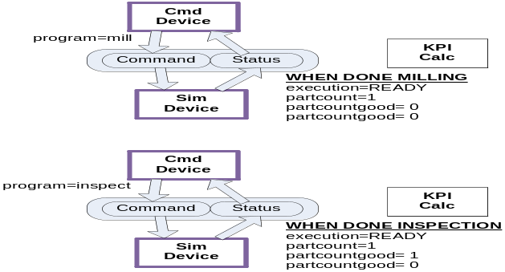

Since uncontrolled process variability can hinder production as measured by KPI, it is imperative that inspection is integrated into the
The Part were defined as Bracket, Shim, and BodyJoint that had an associated sequence of ordered cells (Process Plan) with each cell defined by a Process that had a set of resources and a set of program to run on each resource for each part. Thus, two resources under the same cell and Process step, would have different programs to run for a part. We started with an existing DES commercial software Arena based model, as it was available on the internet. The example with parts steps and initial process times is based on the example from Ch. 6 of “Simulation with Arena” . The example shows a system modeled as four manufacturing cells and where we designated three aerospace part types – shims, body joints, and brackets. In our example, cells 1, 2, and 4 each have a single machine, while Cell 3 has 2 machines a newer faster model and an older one as shown in Figure 3.

From: www.cs.uml.edu/~giam/Mikkeli/IntroToArena.4.ppt
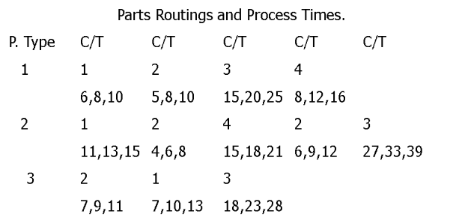
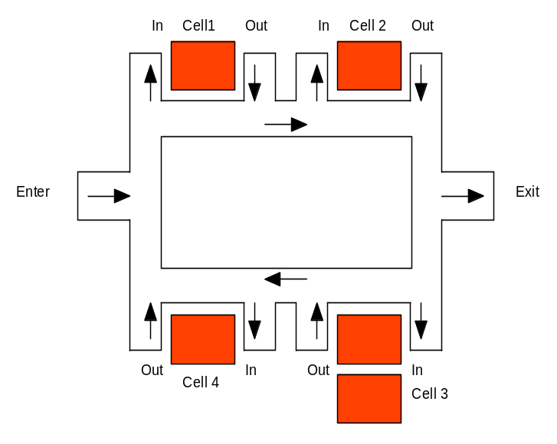
Figure 3 Example Factory Layout and Part Routings

The sequence of cell operations (routing) for each part is presented in Figure 3. The Part Routings and Process Times table provides the order of operations and the times (given as triangular distributions) in the part production routing. The part numbers are 1, 2, 3. The cells are numbered from 1 – 4. For simplicity, without loss of generality, we have added inspection and setup as part of the routing.
Dataset were generated that consisted of recording of MTConnect data from a factory job that describes both part and quantity of parts to be made. Datasets are constructed from the processing of customer orders which triggers the creation of a unique part order (or workorder) within the simulated production system. The creation of a part order (e.g., 10 brackets bumpers, 12 shims, and 15 bodyjoints) is incumbent on the knowledge of the part definition (revision and part), how to build the parts on some set of equipment (process plan), and the required part programs (how to setup, make and inspect the part). All these are combined into jobs to make the parts (and may be scheduled).

A job defines the part mix (which parts) and the part quantities associated with each part. A job has an id for identification, (e.g., “job1”) and then has a list of Part identifiers* and the quantity for each part to be made. Below is the code to define Job1:

Job * job1 = Job::Create<Job>("job1");
job1->partIds.push_back("bracket"); job1->partQuantity.push_back("100");
job1->partIds.push_back("shim"); job1->partQuantity.push_back("75");
job1->partIds.push_back("bodyjoint"); job1->partQuantity.push_back("50");

Each part that can made in the factory is defined. In our case, we have 3 parts: bracket, shim and bodyjoint with associated ids that are used in the Create function for identification and lookup. For each part, we then associate the text of a processplanidentifier for lookup of the process plan to make this part.
Part * bracket = Part::Create<Part>("bracket");
Part * shim = Part::Create<Part>("shim");
Part * bodyjoint = Part::Create<Part>("bodyjoint");

bracket->processplanidentifier="pp1";
shim->processplanidentifier="pp2";
bodyjoint->processplanidentifier="pp3";
Each Process or step is then assigned to a ProcessPlan as part of a sequence of flow through the factory. The important parameters of the ProcessPlan are the identifier (e.g., “pp1”) and the processes required for each process plan ( for pp1: pp1p1, pp1p2, pp1p3 and pp1p4). Below the code defines the process plans by adding processes and saves the process identifiers in lists.

///////////////////////////////////////////////////
ProcessPlan * pp1= ProcessPlan::Create<ProcessPlan>("pp1");
ProcessPlan * pp2= ProcessPlan::Create<ProcessPlan>("pp2");
ProcessPlan * pp3= ProcessPlan::Create<ProcessPlan>("pp3");

pp1->processes.push_back(pp1p1); pp1->processIds.push_back(pp1p1->identifier);
pp1->processes.push_back(pp1p2); pp1->processIds.push_back(pp1p2->identifier);
pp1->processes.push_back(pp1p3); pp1->processIds.push_back(pp1p3->identifier);
pp1->processes.push_back(pp1p4); pp1->processIds.push_back(pp1p4->identifier);

pp2->processes.push_back(pp2p1); pp2->processIds.push_back(pp2p1->identifier);
pp2->processes.push_back(pp2p2); pp2->processIds.push_back(pp2p2->identifier);
pp2->processes.push_back(pp2p3); pp2->processIds.push_back(pp2p3->identifier);
pp2->processes.push_back(pp2p4); pp2->processIds.push_back(pp2p4->identifier);
pp2->processes.push_back(pp2p4); pp2->processIds.push_back(pp2p5->identifier);

pp3->processes.push_back(pp2p2); pp2->processIds.push_back(pp2p2->identifier);
pp3->processes.push_back(pp2p1); pp2->processIds.push_back(pp2p1->identifier);
pp3->processes.push_back(pp2p3); pp2->processIds.push_back(pp2p3->identifier);
Next, the processes that are used to produce parts is defined. Each process is part of process plan, so the naming convention is pp#p# where pp# is the process plan number, and the p# is the plan number. Thus, pp2p1 is process plan 2 process 1 definition. Of importance in a process plan step is the resourcesRequired, and the programs used in the process plan.
Process * pp1p1= Process::Create<Process>("pp1p1");
Process * pp1p2= Process::Create<Process>("pp1p2");
Process * pp1p3= Process::Create<Process>("pp1p3");
Process * pp1p4= Process::Create<Process>("pp1p4");

pp1p1->resourcesRequired.push_back("c1");
pp1p1->AddProperty("Program","Setup1","","Setup pp1 for process 1");
pp1p1->AddProperty("Program","Machine1","","Machining pp1 in process 1");

pp1p2->resourcesRequired.push_back("c2");
pp1p2->AddProperty("Program","Setup2","","Setup for pp1 process 2");
pp1p2->AddProperty("Program","Machine2","","Machining pp1 in process 2");

pp1p3->resourcesRequired.push_back("c3");
pp1p3->AddProperty("Program","Setup1","","Setup for pp1 process 3");
pp1p3->AddProperty("Program","Machine1","","Machining pp1 in process 3");

pp1p3->resourcesRequired.push_back("c4");
pp1p3->AddProperty("Program","Setup2","","Setup for pp1 process 4");
pp1p3->AddProperty("Program","Machine2","","Machining pp1 in process 4");

Process * pp2p1= Process::Create<Process>("pp2p1");
Process * pp2p2= Process::Create<Process>("pp2p2");
Process * pp2p3= Process::Create<Process>("pp2p3");
Process * pp2p4= Process::Create<Process>("pp2p4");
Process * pp2p5= Process::Create<Process>("pp2p5");

pp2p1->resourcesRequired.push_back("c1");
pp2p1->AddProperty("Program","Setup1","","Setup pp1 for process 1");
pp2p1->AddProperty("Program","Machine1","","Machining pp1 in process 1");

pp2p2->resourcesRequired.push_back("c2");
pp2p2->AddProperty("Program","Setup2","","Setup for pp1 process 2");
pp2p2->AddProperty("Program","Machine2","","Machining pp1 in process 2");

pp2p3->resourcesRequired.push_back("c4");
pp2p3->AddProperty("Program","Setup1","","Setup for pp1 process 3");
pp2p3->AddProperty("Program","Machine1","","Machining pp1 in process 3");

pp2p4->resourcesRequired.push_back("c2");
pp2p4->AddProperty("Program","Setup1","","Setup for pp1 process 3");
pp2p4->AddProperty("Program","Machine1","","Machining pp1 in process 3");

pp2p5->resourcesRequired.push_back("c3");
pp2p5->AddProperty("Program","Setup3","","Setup for pp1 process 3");
pp2p5->AddProperty("Program","Machine3","","Machining pp1 in process 3");

Process * pp3p1= Process::Create<Process>("pp2p1");
Process * pp3p2= Process::Create<Process>("pp2p2");
Process * pp3p3= Process::Create<Process>("pp2p3");

pp3p1->resourcesRequired.push_back("c2");
pp3p1->AddProperty("Program","Setup2","","Setup for pp1 process 3");
pp3p1->AddProperty("Program","Machine2","","Machining pp1 in process 3");

pp3p2->resourcesRequired.push_back("c1");
pp3p2->AddProperty("Program","Setup2","","Setup for pp1 process 2");
pp3p2->AddProperty("Program","Machine2","","Machining pp1 in process 2");

pp3p3->resourcesRequired.push_back("c3");
pp3p3->AddProperty("Program","Setup1","","Setup for pp1 process 3");
pp3p3->AddProperty("Program","Machine1","","Machining pp
Next, we define the cells in the factory, which is a collection of resource. The cell collection can contain only one resource, or in the case of cell 3, can contain 2 resources from which to use, r3old and r3new. Thus, the C++ statements
c3->resourceIds.push_back("r3old");
c3->resourceIds.push_back("r3new");

used the bstr collection of resourceIds to add the ids of r3old and r3new to the cell c3. The overall code for defining the cells is as follows:

Cell * c1 = Cell::Create<Cell>("c1");
c1->resourceIds.push_back("r1");

Cell * c2 = Cell::Create<Cell>("c2");
c2->resourceIds.push_back("r2");

Cell * c3 = Cell::Create<Cell>("c3");
c3->resourceIds.push_back("r3old");
c3->resourceIds.push_back("r3new");

Cell * c4 = Cell::Create<Cell>("c4");
c4->resourceIds.push_back("r4");
The factory is defined by using a basic skeleton of a resources, cells, part, process plans, process and job definitions. CMSD defines more factory and simulation elements, but for understanding purposes,
First, we define the resources in the resources,

Resource * r1 = Resource::Create<Resource>("r1");
Resource * r2 = Resource::Create<Resource>("r2");
Resource * r3old = Resource::Create<Resource>("r3old");
Resource * r3new = Resource::Create<Resource>("r3new");
Resource * r4 = Resource::Create<Resource>("r4");

ANALYSIS
KPI issues
Simulation issues – planning involves shifts, schedules, calendars, and holidays.
Resource Faults - In a mature manufacturing system, the occurrence of machine fault conditions is infrequent and this phenomenon inadvertently creates an imbalance between the class distributions of the data [,].
Inspection simulation and results.

C&C Manufacturing came up with a simple and affordable way to ensure machines don’t sit idle for long periods of time. The Short Stop wireless device alerts machine operators when a cycle is complete
Still, across all of these markets, he says that what machine tool users want is reliability, speed, economy, ease of use, ease of service and responsiveness when there is a service need.

http://www.actsolutions.it/File/Arena/Arena%20User's%20Guide.pdf
Ching, Chuen Teck; Li, Xiang; Zhou, Junhong; Li, Xiaoli; Cao, Hong; Woon, David; Hybrid rebalancing approach to handle imbalanced dataset for fault diagnosis in manufacturing systems. Proceedings of the 2012 7th IEEE Conference on Industrial Electronics and Applications, ICIEA 2012, p 1224-1229.
Adam, Asrul; Chew, Lim Chun; Shapiai, Mohd Ibrahim; Jau, Lee Wen; Ibrahim, Zuwairie; Khalid, Marzuki A hybrid artificial neural network-naive bayes for solving imbalanced dataset problems in semiconductor manufacturing test process: Proceedings of the 2011 11th International Conference on Hybrid Intelligent Systems, HIS 2011, p 133-138, 2011, Proceedings of the 2011 11th International Conference on Hybrid Intelligent Systems, HIS 2011

